

Cloud Development

POE PART 1



sIPHESIHLE ZWANE

ST10443356

Table of Contents

### Github Repo Link

https://github.com/ST10443356-Siphesihle-Zwane/CloudPOEPart1.git

### Azure Link

st10443356.azurewebsites.net

### Screenshots

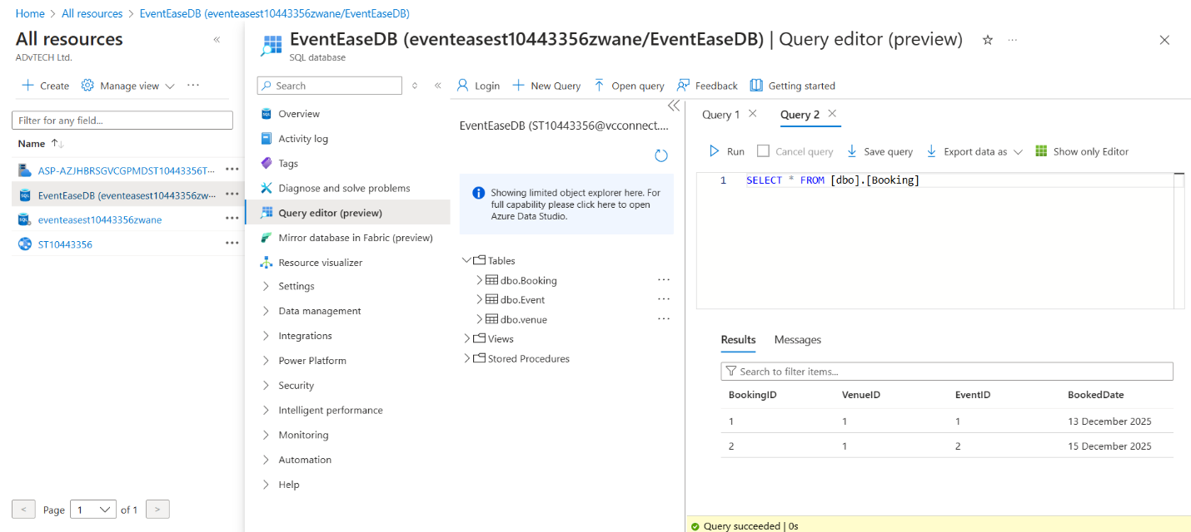

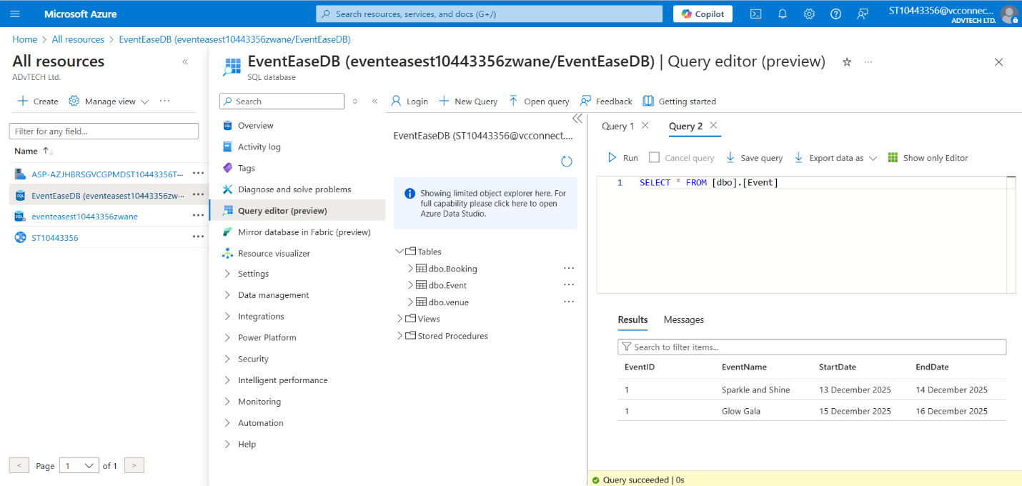

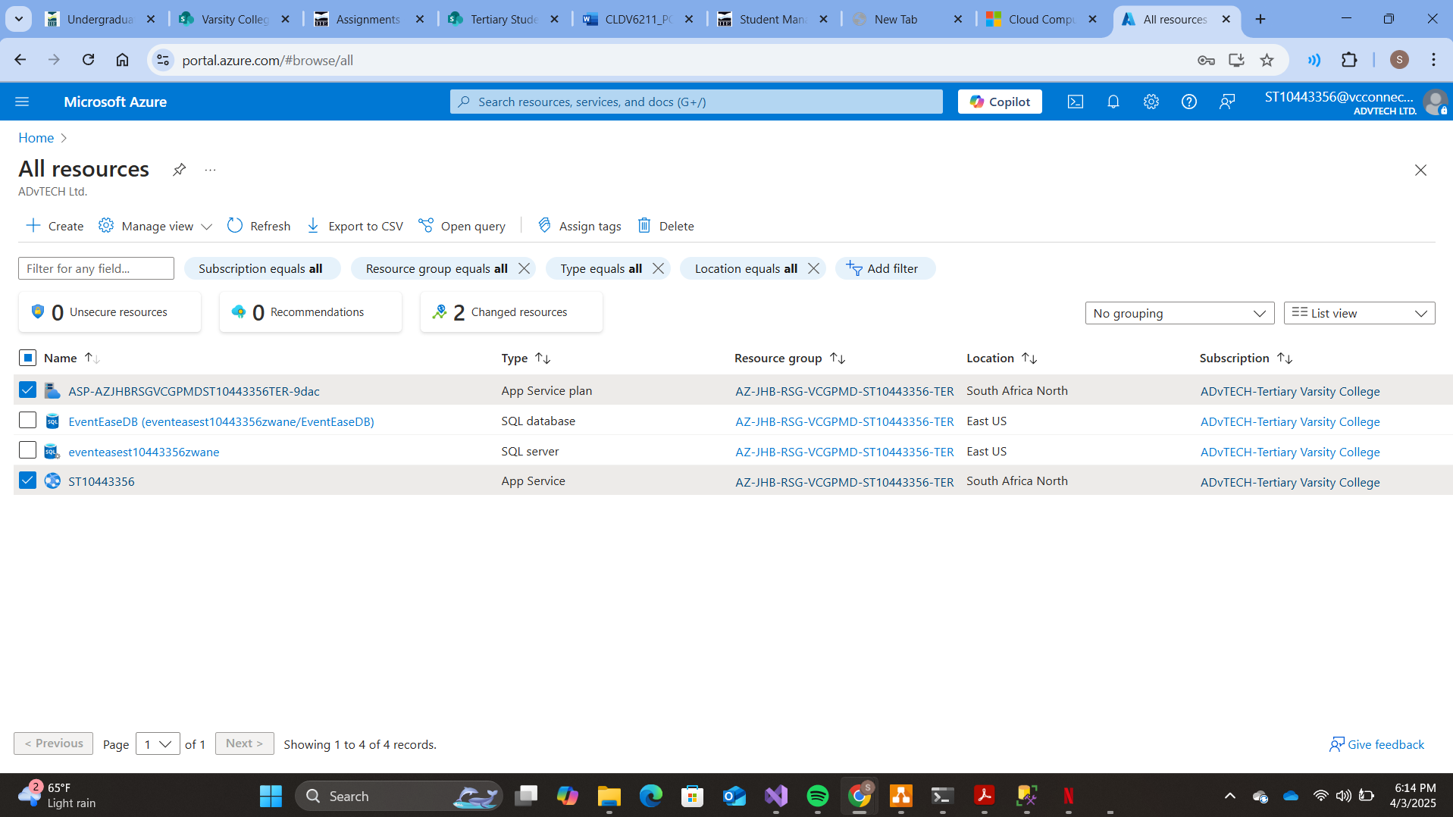

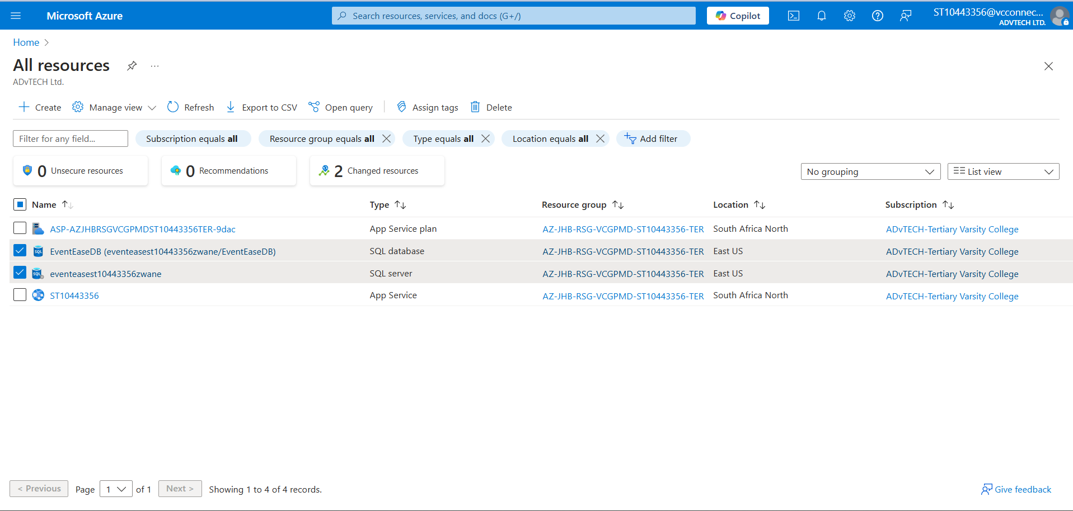

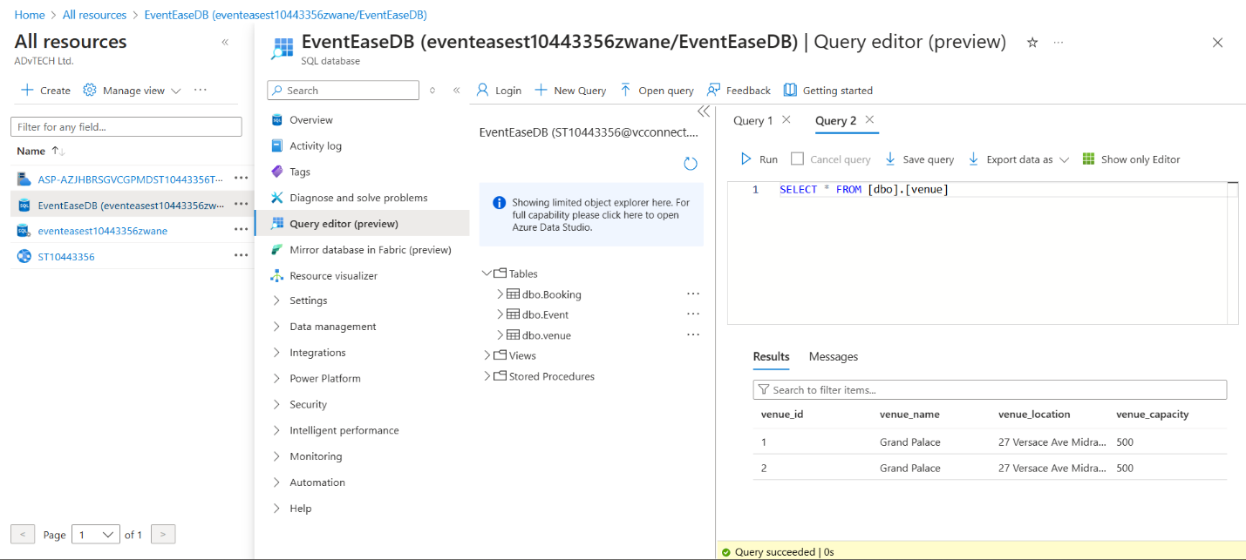

## 

## D. Cloud Computing Basics

Number 1

Security

* Cloud: It is managed by the cloud provider with firewalls, encryption and access controls built-in. An example would be Azure or AWS.
* On-Premises: All measures of security are handled by the business, including firewall configuration, intrusion detection and system updates.

Deployment speed

* Cloud: Automated services like AWS Elastic Beanstalk, Azure App Services and other services can used to deploy applications in a matter of minutes.
* On-Premises: Applications can take up to days or weeks to deploy because they require manual provisioning and configuration of servers.

Resource Management

* Cloud: Resources are adjusted based on demand, thanks to Auto-scaling. An example would be AWS Auto Scaling.
* On-Premises: Higher costs and potential downtime due to businesses having to physically upgrade servers and manage storage.

Example

Taking EventEase as an example:

* Deploying on Azure or AWS would provide fast deployment, automatic scaling, and built-in security.
* On-premises deployment would require purchasing physical servers, IT staff, and security infrastructure, making it costly and time-consuming.

Number 2

**Infrastructure as a Service (IaaS)**

Virtualized computing resources, including as virtual machines, networking, and storage, are made available to organizations via Infrastructure as a Service (IaaS) and can be set up according to particular needs. With this paradigm, businesses can fully manage their infrastructure without having to worry about maintaining real servers. IaaS solutions that provide dynamic resource scaling for enterprises include Google Compute Engine, AWS EC2, and Azure Virtual Machines. IaaS is perfect for businesses who don't want to spend money on on-premises hardware but yet need substantial flexibility, control, and unique configurations for their IT environment. However, as companies are in charge of maintaining their operating systems, security patches, and application configurations, administering IaaS still calls for IT know-how.

**Platform as a Service (PaaS)**

With Platform as a Service (PaaS), developers can concentrate on creating code while the cloud provider takes care of infrastructure, security, and scaling. PaaS provides a completely managed platform for development and deployment. AWS Elastic Beanstalk, Azure App Services, and Google App Engine are a few examples of PaaS that make it easier to deploy apps without forcing companies to maintain the underlying infrastructure. Because it speeds up development cycles and simplifies infrastructure administration, this architecture is especially advantageous for businesses creating specialized applications. Businesses may lower maintenance expenses while maintaining the security and efficiency of their apps because the cloud provider takes care of updates, security patches, and scalability automatically.

**Software as a Service (SaaS)**

With Software as a Service (SaaS), users can access pre-made programs via a web browser without having to worry about managing or installing software. Dropbox, Microsoft 365, and Google Workspace are examples of popular SaaS systems that provide pre-built features to meet a range of corporate requirements. SaaS is the greatest choice for businesses seeking cheaper upfront expenses, rapid setup, and less IT involvement. However, because companies are forced to rely on the functionality offered by the service provider, SaaS's primary drawback is its lack of adaptability. Because of this, SaaS is less appropriate for companies like EventEase, who need a customized booking system that fits their unique business processes.

**Why PaaS is the Best Choice for EventEase**

PaaS is the best option for EventEase compared to IaaS and SaaS. EventEase need a scalable, affordable, and user-friendly platform that enables quick deployment without worrying about server maintenance because they are creating a custom venue booking system. EventEase's operational overhead and complexity would increase if they adopted IaaS since they would have to manually configure and maintain virtual machines. However, depending solely on SaaS—like a third-party booking platform—would not offer the flexibility and customization required for their particular company model. EventEase can effectively create, deploy, and scale its booking system while reducing maintenance efforts and guaranteeing high availability as the business expands by selecting a PaaS solution like Azure App Services or AWS Elastic Beanstalk.

Security

Cloud: It is managed by the cloud provider with firewalls, encryption and access controls built-in. An example would be Azure or AWS.

On-Premises: All measures of security are handled by the business, including firewall configuration, intrusion detection and system updates.

Deployment speed

Cloud: Automated services like AWS Elastic Beanstalk, Azure App Services and other services can used to deploy applications in a matter of minutes.

On-Premises: Applications can take up to days or weeks to deploy because they require manual provisioning and configuration of servers.

Resource Management

Cloud: Resources are adjusted based on demand, thanks to Auto-scaling. An example would be AWS Auto Scaling.

On-Premises: Higher costs and potential downtime due to businesses having to physically upgrade servers and manage storage.

Example

Taking EventEase as an example:

Deploying on Azure or AWS would provide fast deployment, automatic scaling, and built-in security.

On-premises deployment would require purchasing physical servers, IT staff, and security infrastructure, making it costly and time-consuming.

## Referencing

Studocu, 2025. *In what ways does deploying an application in the cloud differ from deploying it on-premises?* [online] Available at: <https://www.studocu.com/en-za/messages/question/11900966/in-what-ways-does-deploying-an-application-in-the-cloud-differ-from-deploying-it-on-premises> [Accessed 3 April 2025].